Web Design Group project

Group H – Ryan Buckley, Cathal Conway, Omar Mohamed Bawazir

**Image ideas**

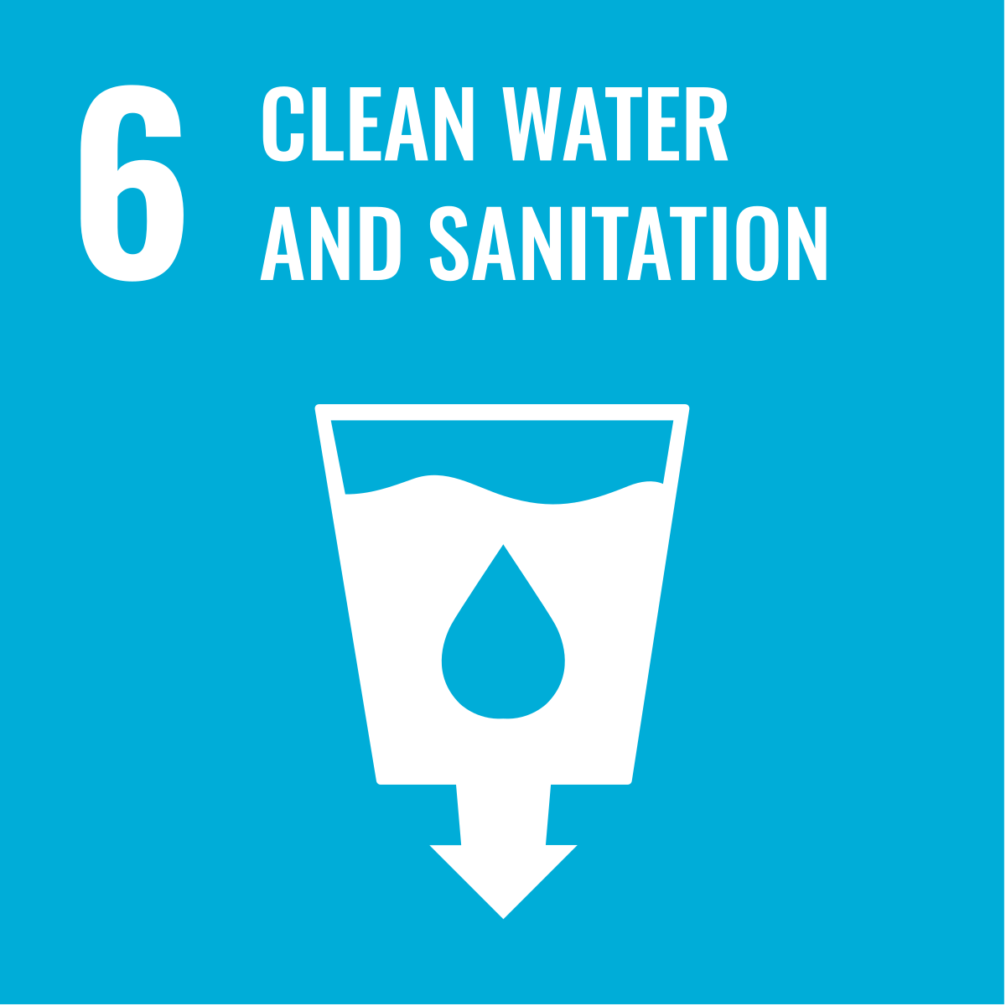

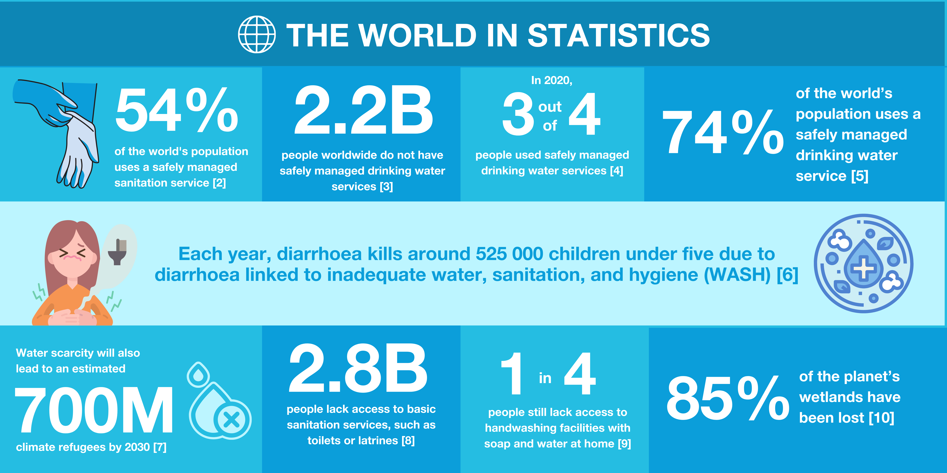

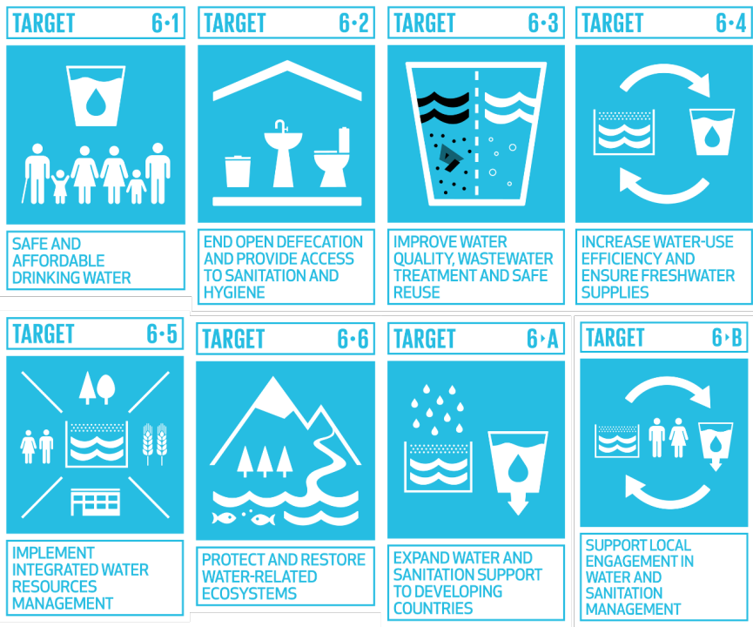

**Colours and fonts**

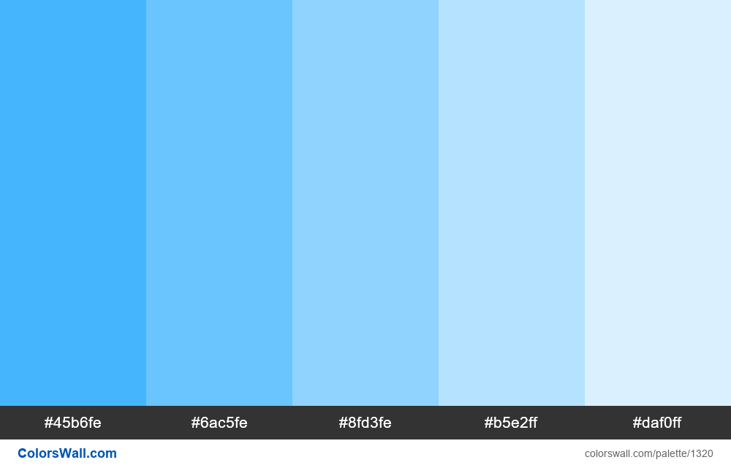

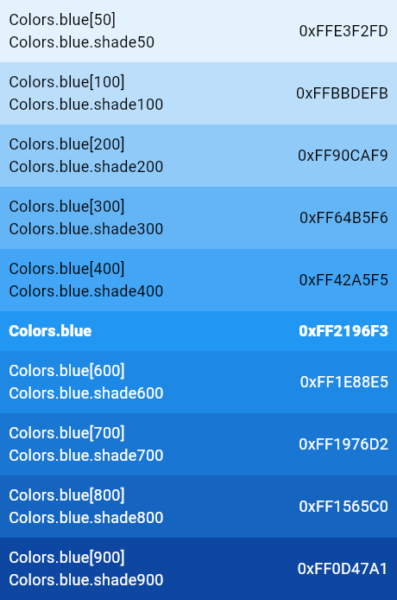



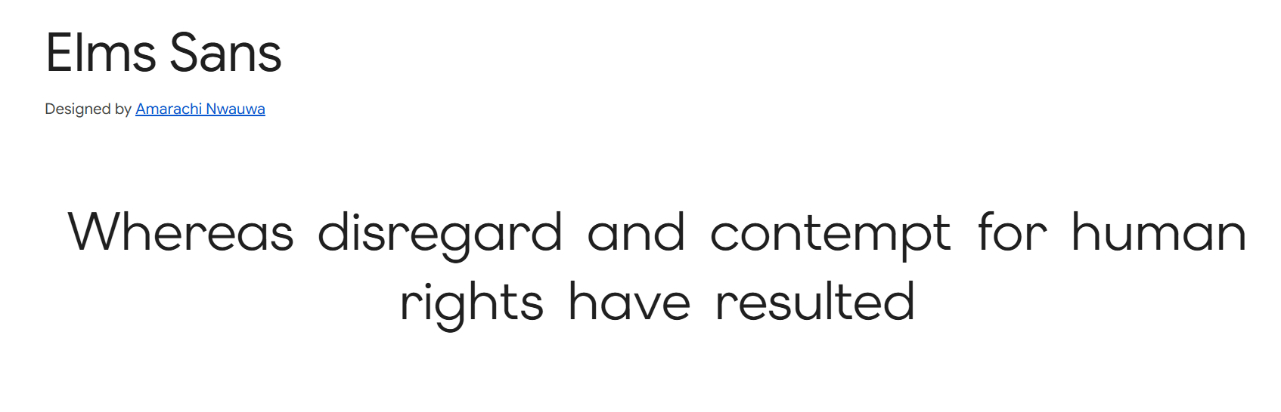

**SITEMAP**

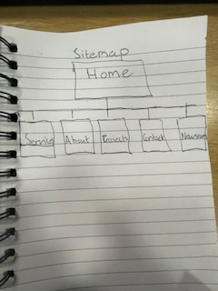

**WIREFRAMES**

**Home page(desktop) RB**

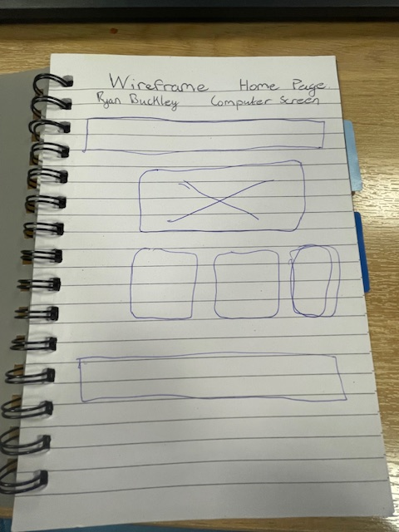

**Homepage – Mobile phone RB**

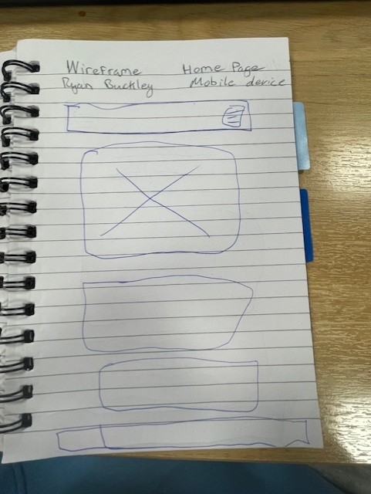

**Contacts page – Desktop RB**

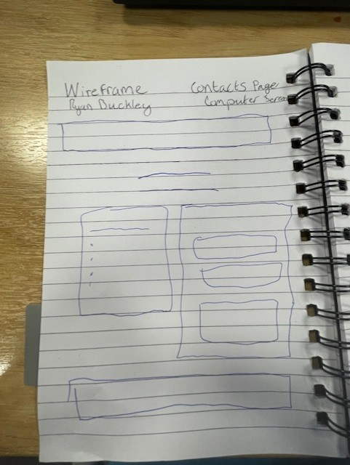

**Contacts page – Mobile phone RB**

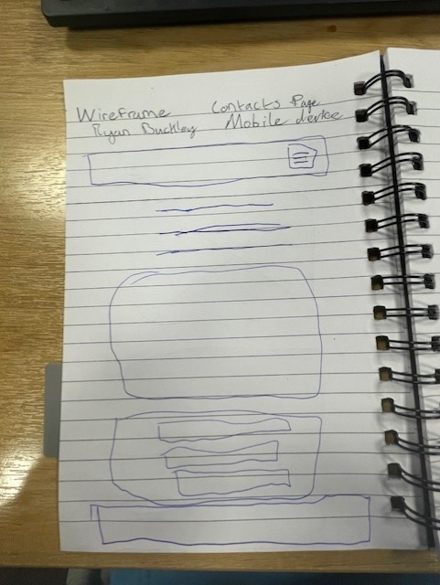

**services page(desktop) omar Bawazir**

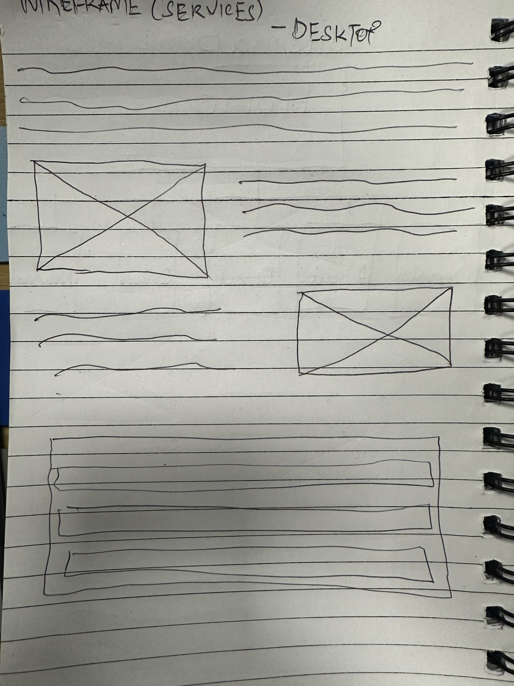

**services page(mobile) omar bawazir**

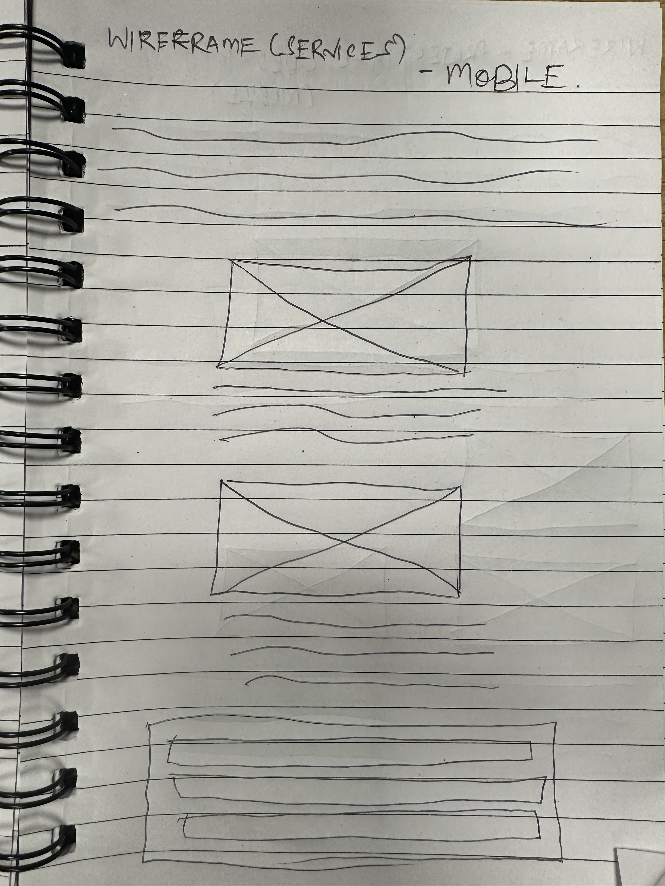

**project page(desktop) omar bawazir**

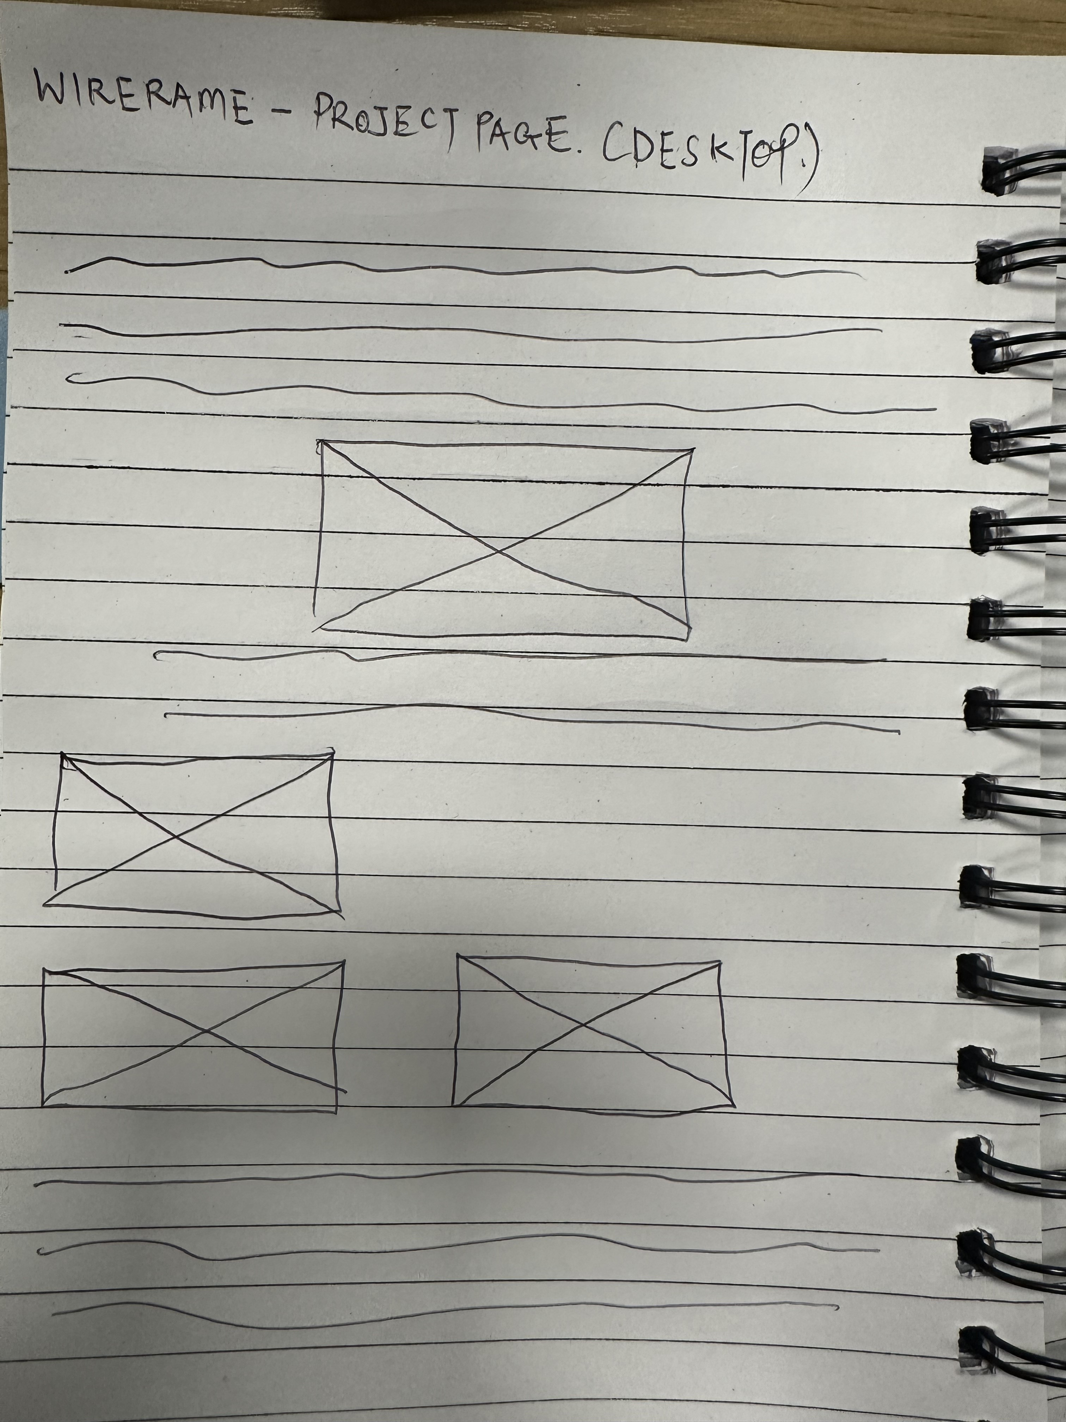

**project page(mobile) omar bawazir**

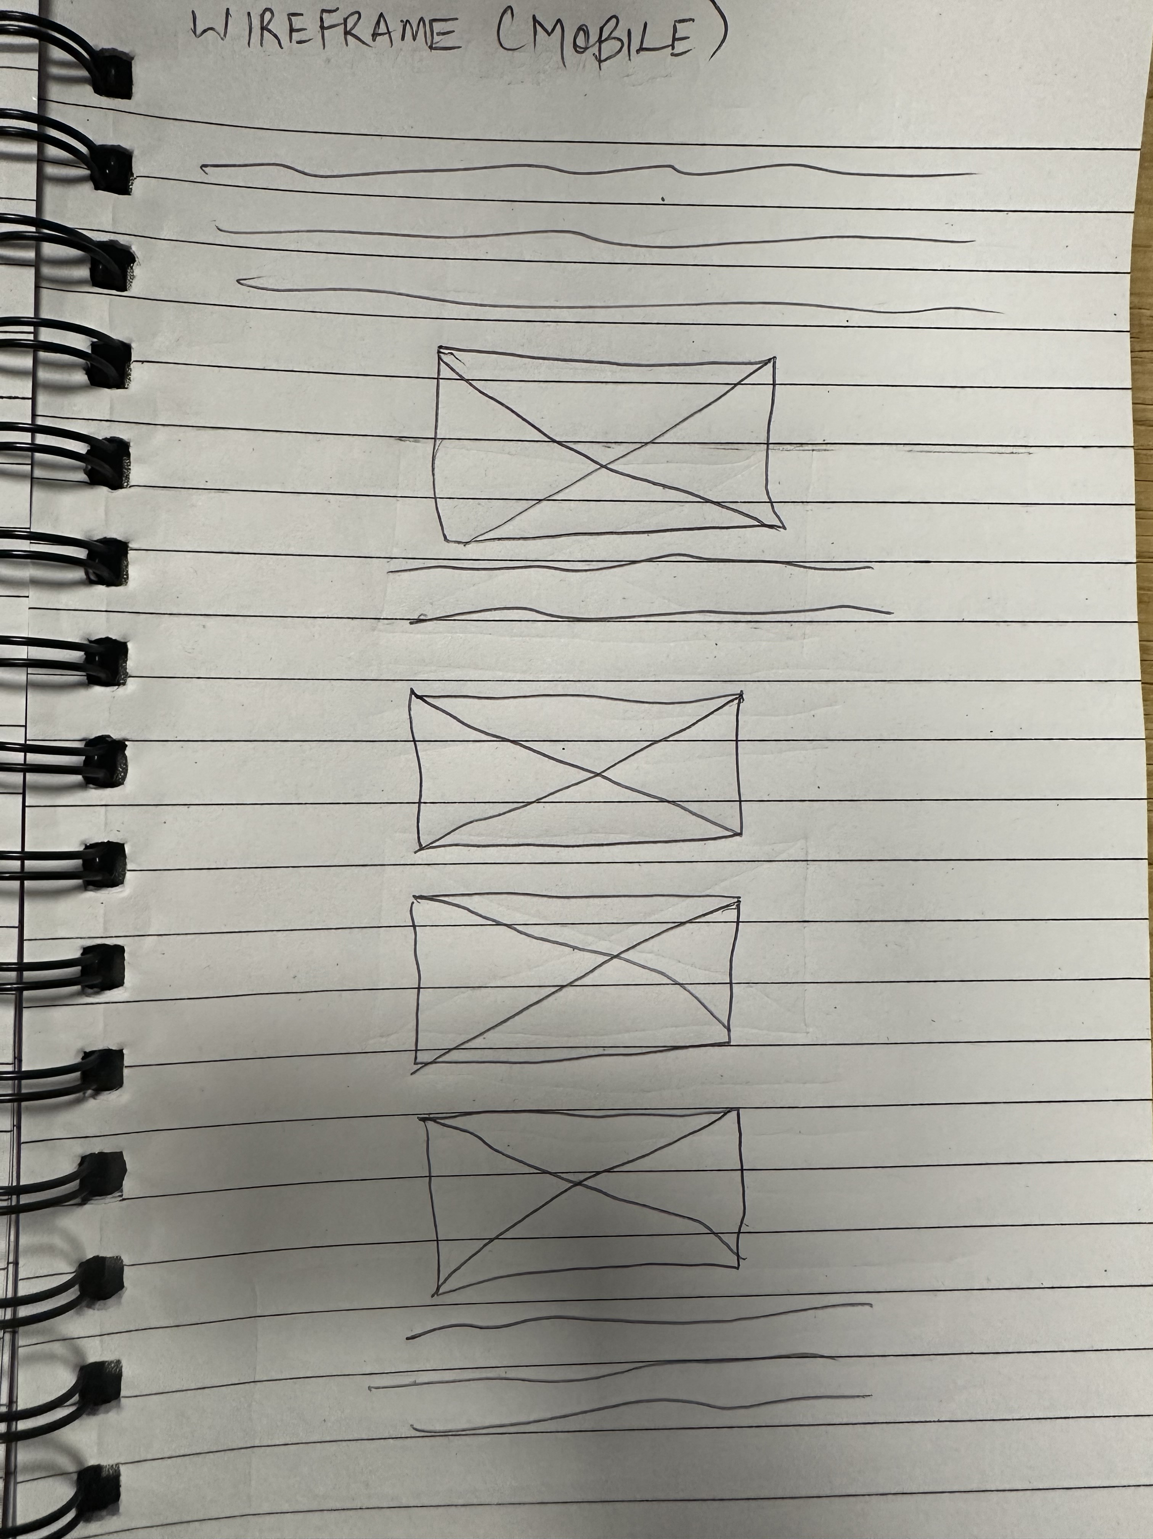

About us (Desktop) Cathal Conway - <https://github.com/Cathal100/groupproject.git>

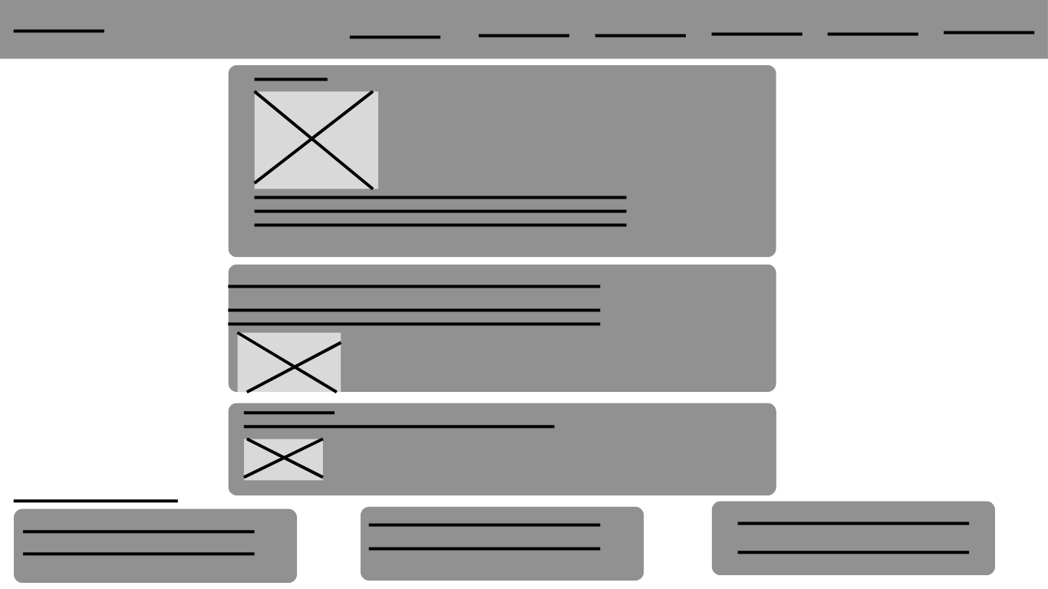

About Us (Mobile Phone)

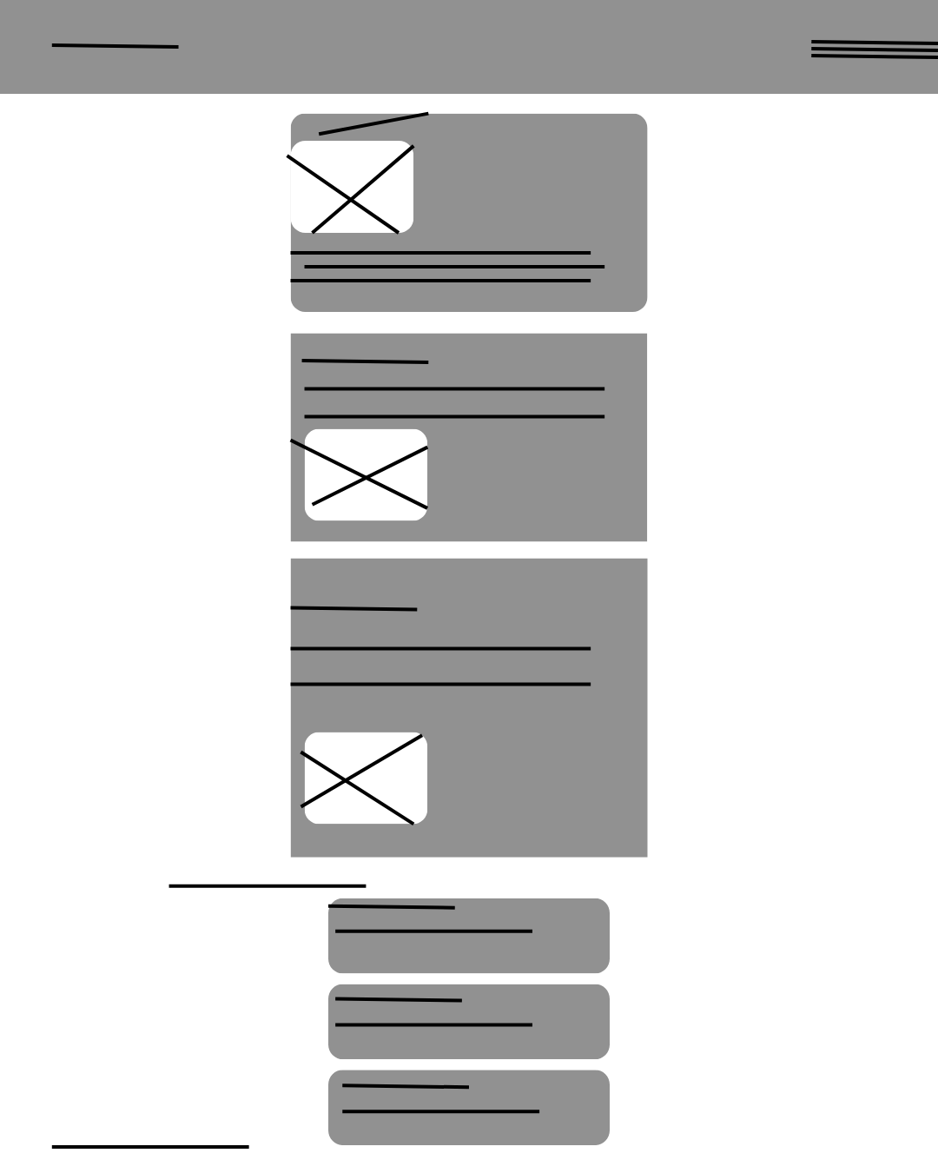

Newsroom (Desktop) - Cathal Conway



Newsroom (Mobile Phone)

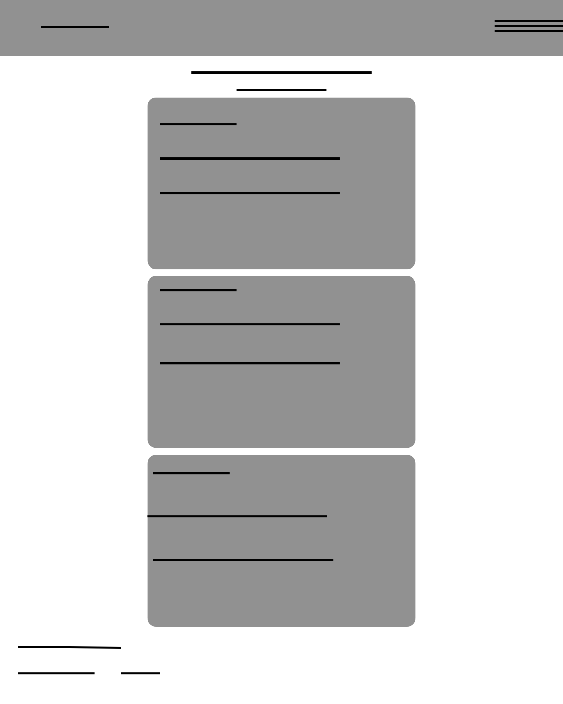

S

**GitHub links**

<https://github.com/Cathal100/groupproject.git> - Cathal Conway

[Bawazir985/Bawazir-folded](https://github.com/Bawazir985/Bawazir-folded) - Omar Bawazir

<https://github.com/ryanbuckley2912/wdd_GroupProject.git> - Ryan Buckley

HTML VALIDATION

**Project Page(Before the correction)**

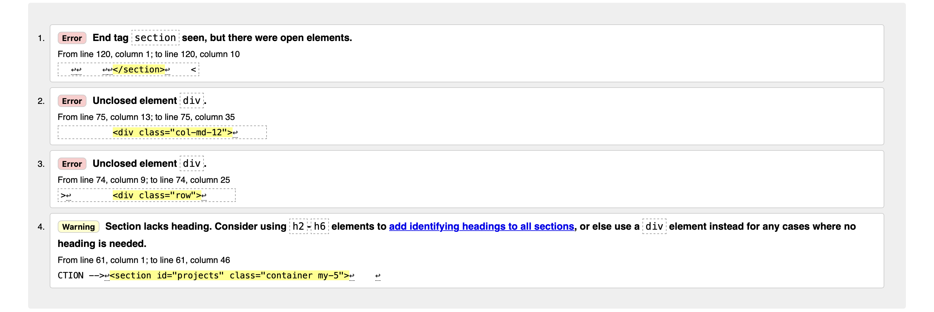

**Project Page(after the correction)**

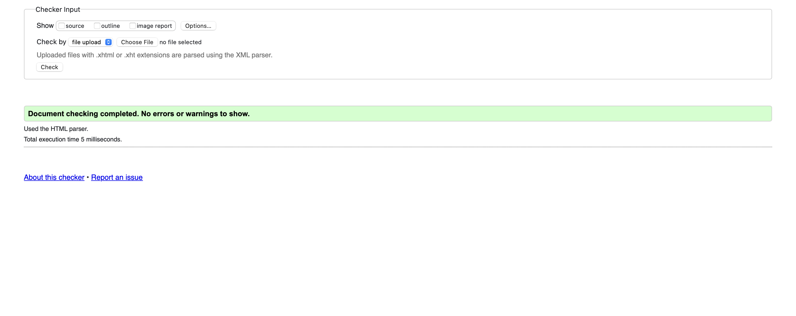

About page - Cathal

before

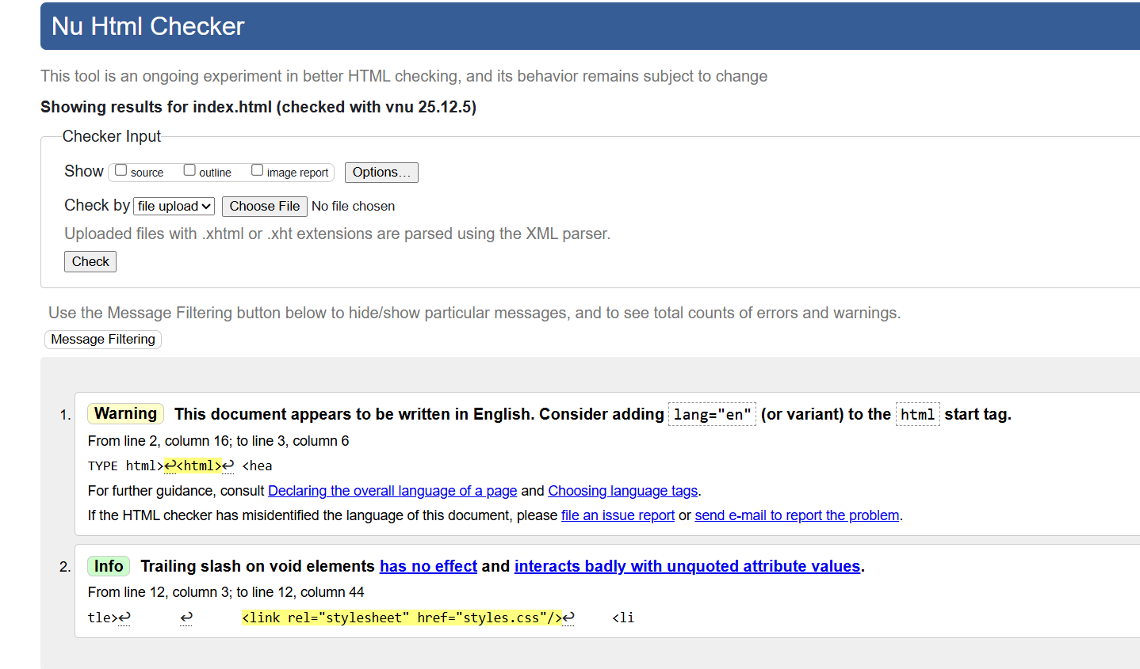

After:

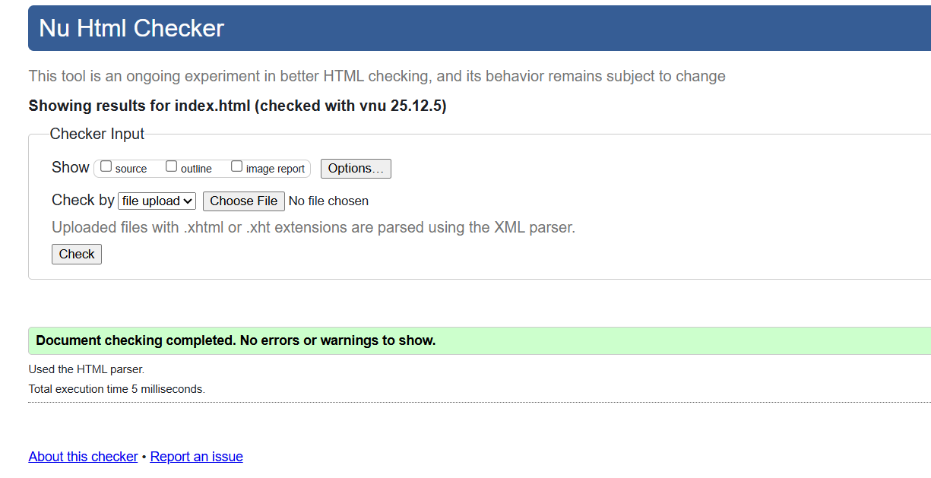

News room – Cathal

No corrections needed.

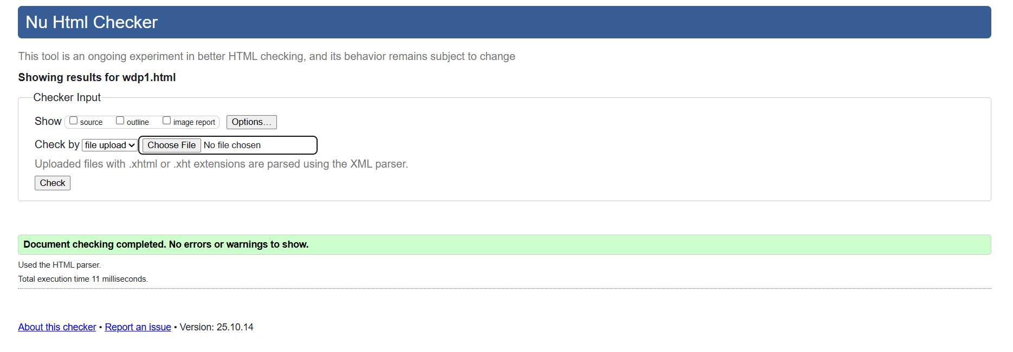

Weekly break down

